**VISVESVARAYA TECHNOLOGICAL UNIVERSITY, BELAGAVI**



**B.L.D.E.A’S V. P. Dr. P. G. HALAKATTI COLLEGE OF**

**ENGINEERING AND TECHNOLOGY,**

**VIJAYPUR - 586103**



**DEPARTMENT OF COMPUTER SCIENCE AND ENGINEERING**

WEB TECHNOLOGYASSIGNMENT PROJECT REPORT

ON

**“HOTEL MANAGEMENT”**

**UNDER THE GUIDANCE OF**

**Prof. Dakshayani M Ijeri**

**SUBMITED BY**

**SUSHMA KULKARNI [2BL21CS412]**

**VISVESVARAYA TECHNOLOGICAL UNIVERSITY, BELAGAVI**



**B.L.D.E.A’S V. P. Dr. P. G. HALAKATTI COLLEGE OF**

**ENGINEERING AND TECHNOLOGY,**

**VIJAYPUR - 586103**



**DEPARTMENT OF COMPUTER SCIENCE AND ENGINEERING**

**CERTIFICATE**

This to certify that the mini project on WEB TECHNOLOGY & ITS APPLICATIONS [18CS63] work entitled “HOTEL MANAGEMENT” is a bonafide work carried out Sushma Kulkarni [2BL21CS412] prescribed by Visveshvaraya Technological University, Belagavi for V semester B.E. Computer Science and Engineering during the year 2022-23.It is certified that all correction and suggestion indicated have been duly incorporated in the report .The report satisfies the academic criteria expected of it and here by stands approved.

(Signature of Guide) (Signature of HOD) (Signature of Principal)

**1. Prof. Dakshayani M Ijeri Dr. PUSHPA PATIL DR. V G SANGAM**

Signature with Date:

**Introduction:**

The motive of our project is to control various activities performed. In the Hotel using the computer with the work of HOTEL MANGEMENT SYSTEM. From the beginning, the important thing in our mind is that we should concentrate our project work on a subject that is easy to understand and is according to our daily requirement. By keeping this in mind, the subject chosen by us is hotel management

.

In the present time there is a great rush in hotels, as these have become necessity for middle and upper class of the society. People travel a lot, stay in hotels, goes to the hotels for functions, meeting and refreshment. Our project is developed keeping in mind the general needs of the customers when he goes to the hospital. An important uniqueness about the described Hotel’s restaurants and bar are available to only those customers who have already booked room or hall in hospital

The present day modern concept of the hotel is not just a place to provide `accommodation, food and beverage, but like city within a city and offering the every possible facilities, accommodation, service and convenience, not such as rooms. There are more facilities like- cosmetic things, hairdryer, cock tail lounges, radio and TV etc. There is a professionally qualified, highly trained, experienced, and efficient. Courteous staff in smart, clean uniforms and the staff coming in the contact With guests could understand English. There is a 24hrs service for reception, information and telephone. There is a plentiful supply of linen, blanket, towels and so on. Each bedroom is provided with good vacuum jug/ thermos flask with ice cold, boiled drinking water.

**HOME PAGE:**

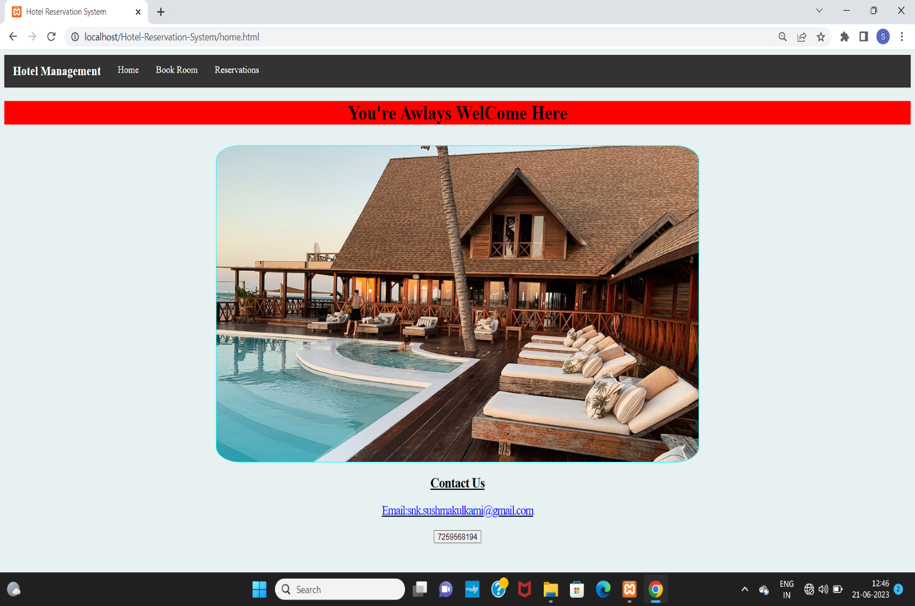

Fig: 1.1 Home page

**ROOM BOOKING:**

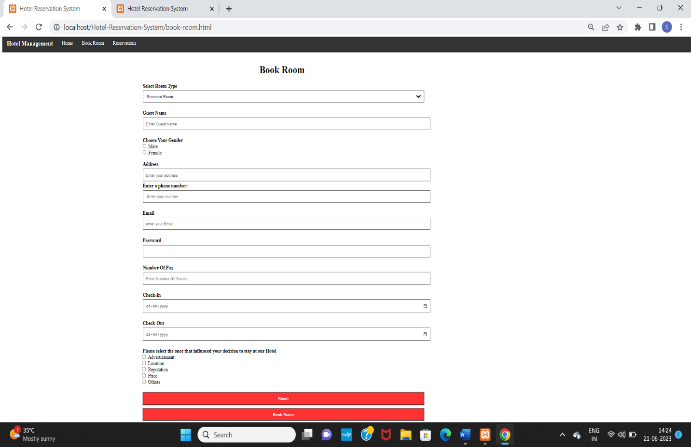

Fig: 1.2 Room Booking Page

**RESERVATION:**

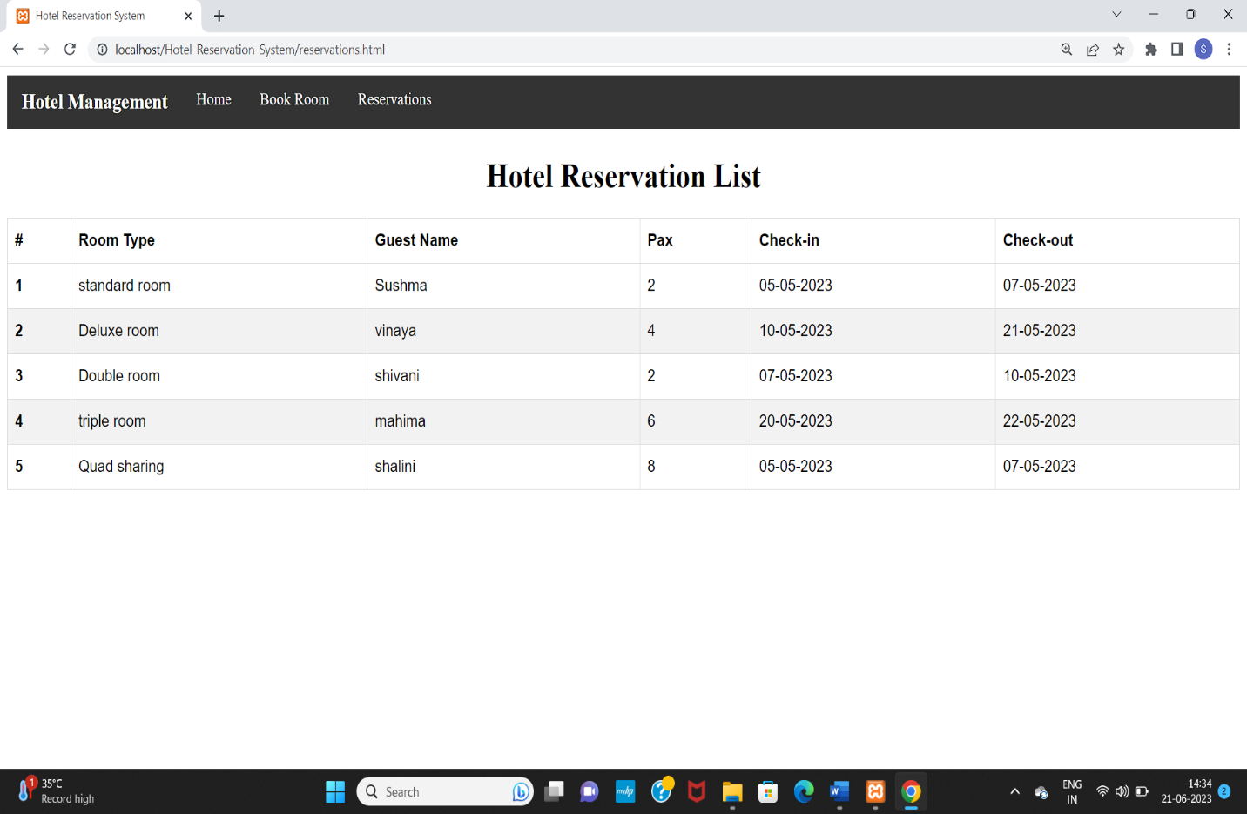

Fig: 1.3 Reservation Page

**SNAPSHOTS:**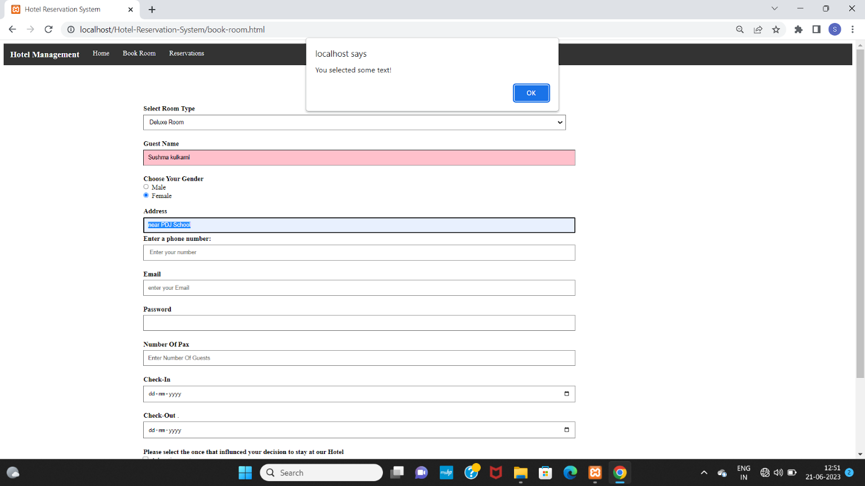

Fig: 1.4 onselect event

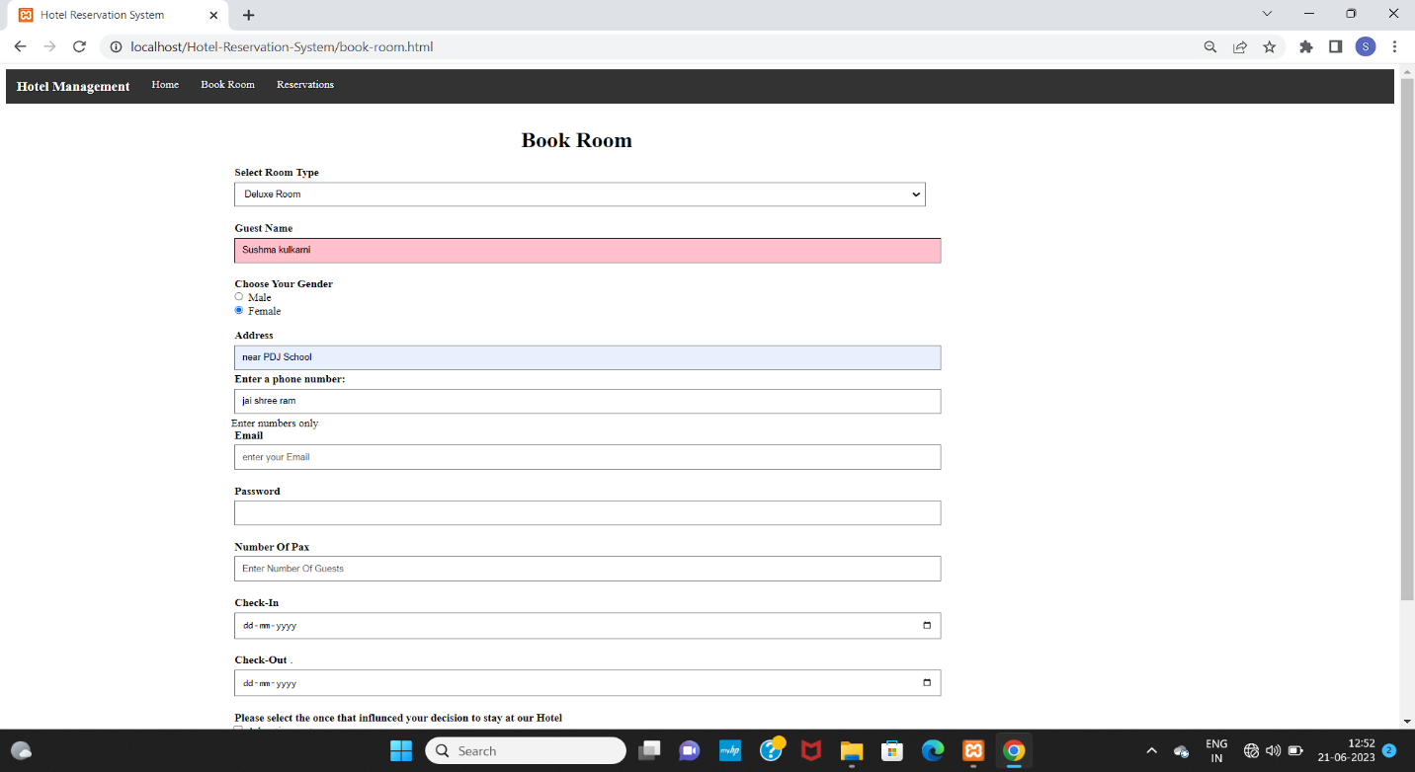

Fig: 1.5 Phone number Validation

It only takes the numerical values if the user enters characters it will gives validation error like ‘Enter a phone numbers’ .

**SNAPSHOTS**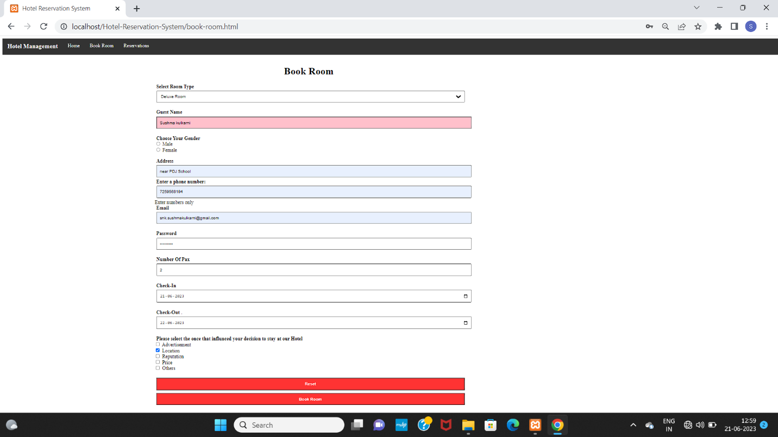

Fig: 1.6 Password Validation

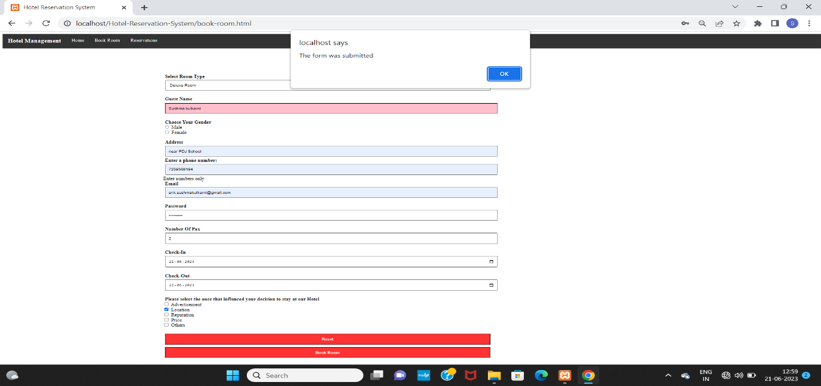

Fig: 1.7 onsubmit event

**RESULT:**

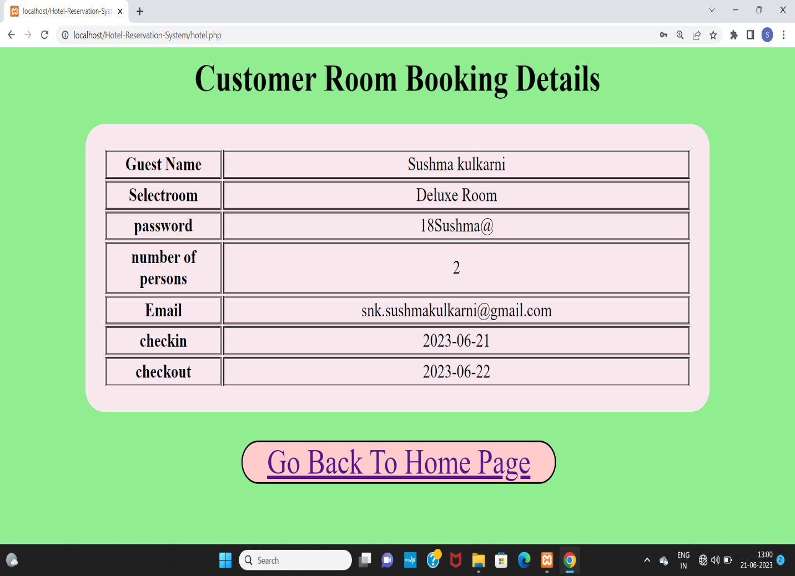

Fig:1.8 Result

After completion of form filling the user will submit. The data will be

Stored at the PHP side on the localhost server. This is the ending of the website.